***COLAISTE NÁISIÚNTA EALAÍNE IS DEARTHA***

***NATIONAL COLLEGE OF ART AND DESIGN***

A Recognised College of University College Dublin

**SCHOOL OF EDUCATION 2023-24**

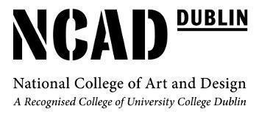

***Evaluation of 4th Year School Placement*** :***BA (JH) Education and Design or Fine Art***

STUDENT: ***Molly Molloy***

SCHOOL: ***Monaghan Collegiate School***

PRINCIPAL: ***Johnston Reid***

ART TEACHER/S: ***David Pollock***

CLASS TIMES/GROUP:

***Tuesday -***

**1st year -** 9:30 - 10:50 (Double) **4th year** - 10:50 - 1:10 - (Double)

***Thursday-***

**5th year** - 11:10 - 12:30 (Double) **1st year -** 12:30 - 1:10 (Single)

**2nd year** - 2:40 - 4:00 (Double)

***Friday*** -

**4th year -** 9:30 - 1:10- (Single) **6th year Visual studies-** 11:50 - 12:30 (single)

**5th year Visual studies-** 2:00 - 2:40 (Single)

***Team Teaching - 3rd year : 2:40 - 4 (Double)***

Monaghan Collegiate School is located on the outskirts of Monaghan town surrounded by beautiful scenery and nature. The school's ethos places a strong emphasis on values, ethics, and community engagement. MCS stands as a distinguished institution, known for its commitment to excellence in education within a private and Protestant framework. Students are encouraged to embody principles of respect, integrity, and empathy, fostering a sense of responsibility to contribute positively to society. I was and am extremely honoured to say I am a past pupil from Monaghan Collegiate School and under the same guidance of my Art teacher, David Pollock.

My teaching has really improved over the past year and I really feel like this is because I was back in my own surroundings. I feel like teaching is the right career for me because I have had such a great experience doing it and especially being back with my Art teacher, David pollock. He allowed me to witness being back in the school on the other side. With the help of my tutors and all the feedback I got on my visits and my tutor tutorials , I believe that I have improved overall in terms of my abilities and traits as well as in terms of how I plan and prepare my lessons and studying material. My ability to interact and respond with the students has increased over the course of the year, and I have been able to establish a strong rapport with them. Teaching in schools with different demographics has given me experience, and I believe this has helped me grow more confident in my approach to my performance in the classroom.

My **Strengths** on this school placement would have been two things. **1)** Classroom management *(Pupils activity and Pupils behaviour)* and **2)** Professional Teaching skills and ability *(Communication, Voice, terminology, personal quality, pupils response).* As this was my 3rd placement and they all were very different, St Kevin's college, Finglas, Dublin and Our Lady’s Secondary School, Blaney, Monaghan it was good to see how to deal with classroom management in each of my schools. Classroom discipline was never an issue in my final school placement as it's a small school with small classes.

My Professional Teaching skills and ability was a strength in this school placement as I felt comfortable and confident. Not having to settle in made my 10 weeks just fly by. I personally found that being back in my old school made me fully feel myself and teach to the best of my ability, it allowed me to slip back into my hobbies like basketball. I was captain for my school basketball team for 6 years and being back and being able to coach the team that I lived for was an honour.

For this school placement we had to base one Unit of learning on our studio practice, mine is TAA. With my 4th year the first block I did crocheting for the first time in the classroom and absolutely loved it and so did my students. I challenged myself by teaching how to make “granny square” blankets. This was one of my favourite UOL’s. I ended up making a youtube page for my students to follow in class and at home “Miss Molloy” I will continue this in my teaching the following year since I believe it will help the children learn on a variety of levels.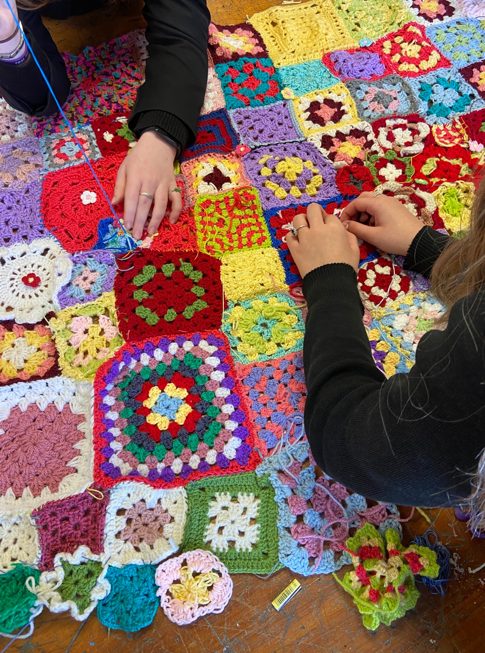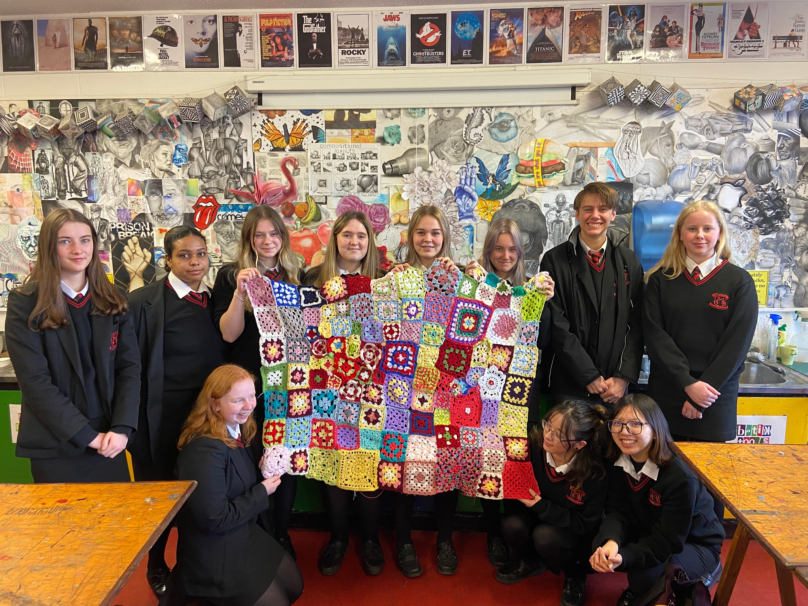

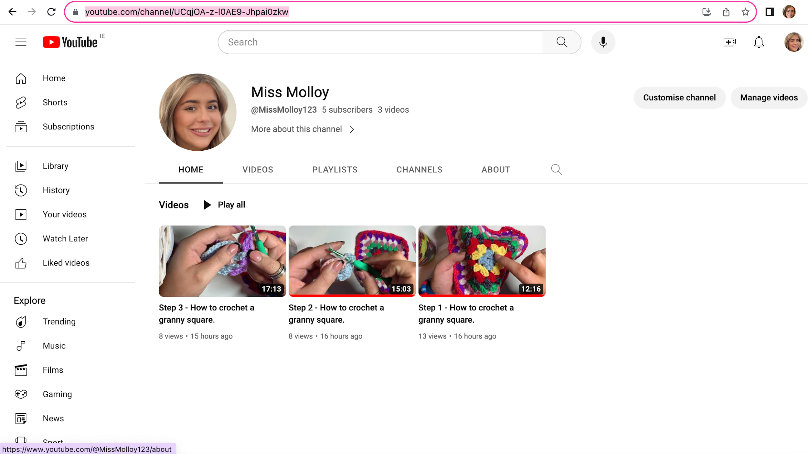

**My Weaknesses** would be my reflections after every lesson and roll call. These are two things that I had to have a note on the top of my laptop to remind me of every lesson to do. Reflections are such an important part of teaching and thankfully a kind and helpful tutor helped me when i got visited on an easier way to reflect.

Thankfully my overall experience of my final placement was positive. I feel like I have matured a lot from my last viva and a big strength was being up in college every week. I know for my viva last year I said that I found it hard being at home and not around my friends and I am very happy we were up this year as it made it easier for me to ask questions and get the answer there and then thank you for that. Having the chance to do a open night and two parent teacher meeting allowed me to gain more confidence before working in the real world